SOFTWARE REQUIREMENTS

SPECIFICATION

FOR

HRM SYSTEM

Revision: 0.0.1

|  |  |  |  |  |  |
| --- | --- | --- | --- | --- | --- |
| **DOCUMENT CHANGE LOG** | | | | | |
| **Revision** | **Description** | **Author** | **Date** | **Approved** | **Date** |
| 0.0.1 | Initial | Vyltm | 08/11/2017 |  |  |
|  |  |  |  |  |  |

Table of Contents

1. INTRODUCTION 6

1.1Purpose 6

1.2 Scope 6

1.3 Definitions, Acronyms, and Abbreviations 6

2. Overall Description 7

2.1 System overview 7

2.2 Use-Case Model Survey 10

2.2.1 Actors 10

2.2.2 Use case model 10

2.3 User Characteristics 14

2.4 Constraints 14

3. Specific Requirements 15

3.1 Client 15

3.1.1 Screen flow 15

3.1.2 UC-C001 – Start Application 16

3.1.3 UC-C002 – Log in 17

3.1.4 UC-C003 – Log out 18

3.1.5 UC-C004 – Register 19

3.1.6 UC-C005 – Login with Facebook 21

3.1.7 UC-C006 – Show Help 23

3.1.8 UC-C007 – Suggest Category Follow 25

3.1.9 UC-C008 – Suggest User Follow from Server Side 26

3.1.10 UC-C009 – Suggest User Follow from Facebook 27

3.1.11 UC-C010 – Suggest User Follow from Contact 29

3.1.12 UC-C011 – Search 30

3.1.13 UC-C012 – Like Video 32

3.1.14 UC-C013 – Comment Video 33

3.1.15 UC-C014 – More Function 35

3.1.16 UC-C015 – Repost 37

3.1.17 UC-C016 – Setting 38

3.1.18 UC-C017 – Message 40

3.1.19 UC-C018 – Notification 41

3.1.20 UC-C019 – Profile 42

3.1.21 UC-C020 – Make Video 43

3.1.22 UC-C021 – Capture Moments 45

3.1.23 UC-C022 – Capture Video 47

3.1.24 UC-C023 – Import File 49

3.1.25 UC-C024 – Import Video 50

3.1.26 UC-C025 – Import Image 52

3.1.27 UC-C026 – Add Music 54

3.3 Supplementary Requirements 56

3.3.1 Deployment Requirements 56

3.3.2 Development Requirements 56

3.3.3 Design Constraints 57

3.3.4 Logging convention 57

3.3.5 Application Versioning Convention 58

3.3.6 Check Points before Release New Version to Market 58

4. Supporting Information 59

4.1 Localization 59

4.2 Interface 59

4.2.1 Log in screen 59

4.2.2 Home screen 60

4.2.3 Search screen 61

4.2.4 Capture Video screen 62

4.2.5 Notification screen 63

4.2.6 Profile screen 64

4.2.7 Discover People screen 65

4.2.8 App Setting screen 66

4.2.9 User Setting screen 67

# 1. INTRODUCTION

## 1.1 Purpose

This document fully describes the behavior of the HRM application. It also describes nonfunctional requirements, design constraints, and other factors necessary to provide a complete and comprehensive description of the requirements of the software

## 1.2 INTRODUCTION

This SRS is only applied for S-Video project

## 1.3 Định nghĩa, từ viết tắt

Bảng 1- Định nghĩa, các từ viết tắt

|  |  |
| --- | --- |
| SRS | Software Requirement Specification |
| GUI | Graphic User Interface |
| API | Application Programming Interface |
| HRM | Human Resource Management |

# 2. Overall Description

## 2.1 System overview

HRM( Human Resource Management) là hệ thống hỗ trợ doanh nghiệp trong công tác quản lý nguồn lực bao gồm: nhân sự, tiền lương, tuyển dụng, đào tạo, chính sách thưởng phạt, báo cáo …

Tài liệu này nhằm mô tả chi tiết các chức năng và luồng thao tác trong các chức năng của hệ thống. Ngoài ra các yêu cầu phi chức năng cũng được mô tả trong tài liệu

## 2.2 User Characteristics

HRM System does not require any specific computer knowledge to use it except the developers and administrators of it. Standard users are thought to be from any age, any gender and from any nationality who can use just computer’s browser. On the other hand, administrators and potential developers need a high level of expertise to understand web technologies.

## 2.3 Constraints

## 2.4 Use-Case Model Survey

### 2.4.1 Actors

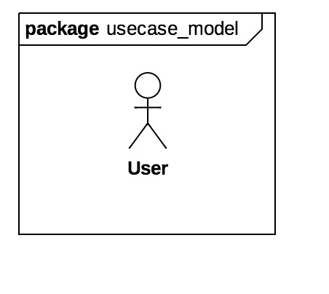

Hình 1 - System User

* User: Người dùng cuối, thao tác trực tiếp trên hệ thống

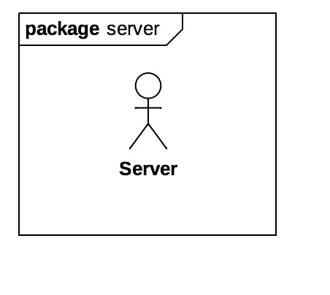

Hình 2 - System Server

* Server: server giao tiếp trong hệ thống.

### 2.4.2 Use case model

### 

Hình 3 – use cases tổng quát

**2.4.2.1 Use case of employee**

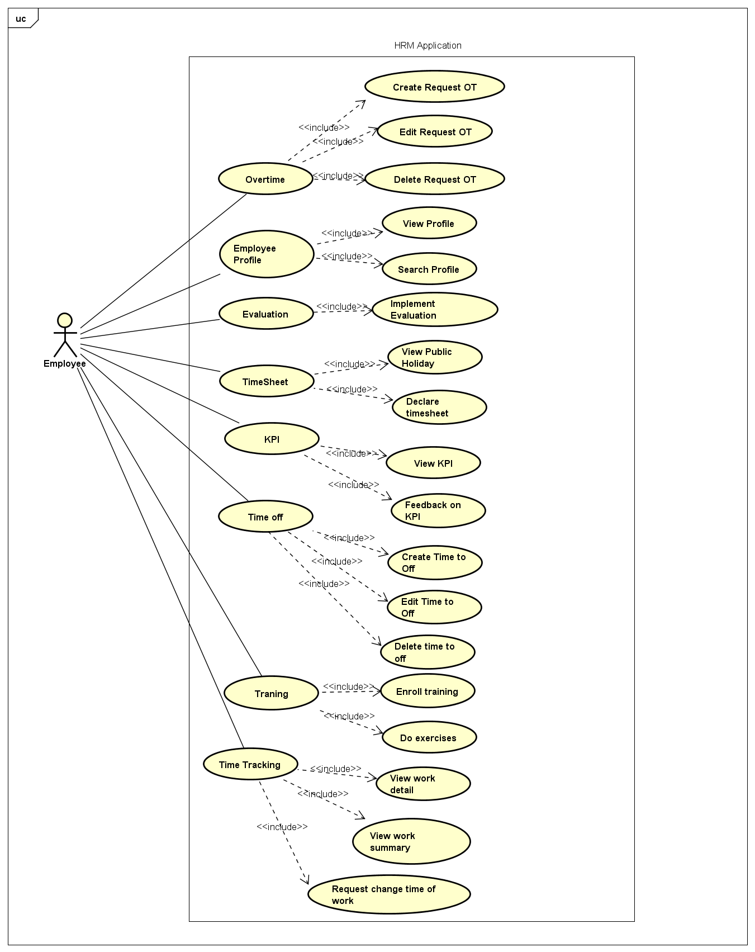

Hình 4: Use case của actor Employee

|  |  |  |
| --- | --- | --- |
| **No.** | **Use Case Name** | **Description** |
| UC-C001 | Login | Allow the user log in into the application |
| UC-C002 | Log out | Allow the user sign out the application |
| UC-C003 | View profile | Allow the user view my profile |
| UC-C004 | View Salary | Allow the user view my salary |
| UC-C005 | Search profile | Allow the user search info of other employee |
| UC-C006 | Time off list | Allow the user view my time off list |
| UC-C007 | Create request for time off | Allow the user create request for time off |
| UC-C008 | Edit request for time off | Allow the user edit request for time off when the request in Create state |
| UC-C009 | Delete request for time off | Allow the user delete request for time off when the request in Create state |
| UC-C010 | View Overtime list | Allow the user view my Overtime list |
| UC-C011 | Create request for overtime | Allow the user create request for Overtime |
| UC-C012 | Edit request for overtime | Allow the user edit request for Overtime when the request in Create state |
| UC-C013 | Delete request for overtime | Allow the user delete request for Overtime when the request in Create state |
| UC-C014 | Declare timesheet | Allow the user declare my timesheets on the application |
| UC-C015 | View public holiday | The application mark public holidays on week calendar |
| UC-C016 | View work detail | Allow the user view work detail in period |
| UC-C017 | View work summary | Allow the user view work summary in period |
| UC-C018 | Request change time of work | Allow the user create Request change time of work |
| UC-C019 | View KPI list | Allow the user view KPI list is published from leader |
| UC-C020 | View KPI detail | Allow the user view KPI detail from KPI list |
| UC-C021 | Feedback on KPI | Allow the user feedback on KPI is assigned |
| UC-C022 | View evaluation list | Allow the user view evaluation list is published from leader |
| UC-C023 | Implement evaluation | Allow the user implement on evaluation is assigned |
| UC-C024 | View training list | Allow the user view training session is assigneed |
| UC-C025 | View traning information | Allow the user view traning information |
| UC-C026 | Do exercises | Allow the user attach my exercises of traning session |

# 3. Specific Requirements

## 3.1 Employee

### 3.1.1 Screen flow

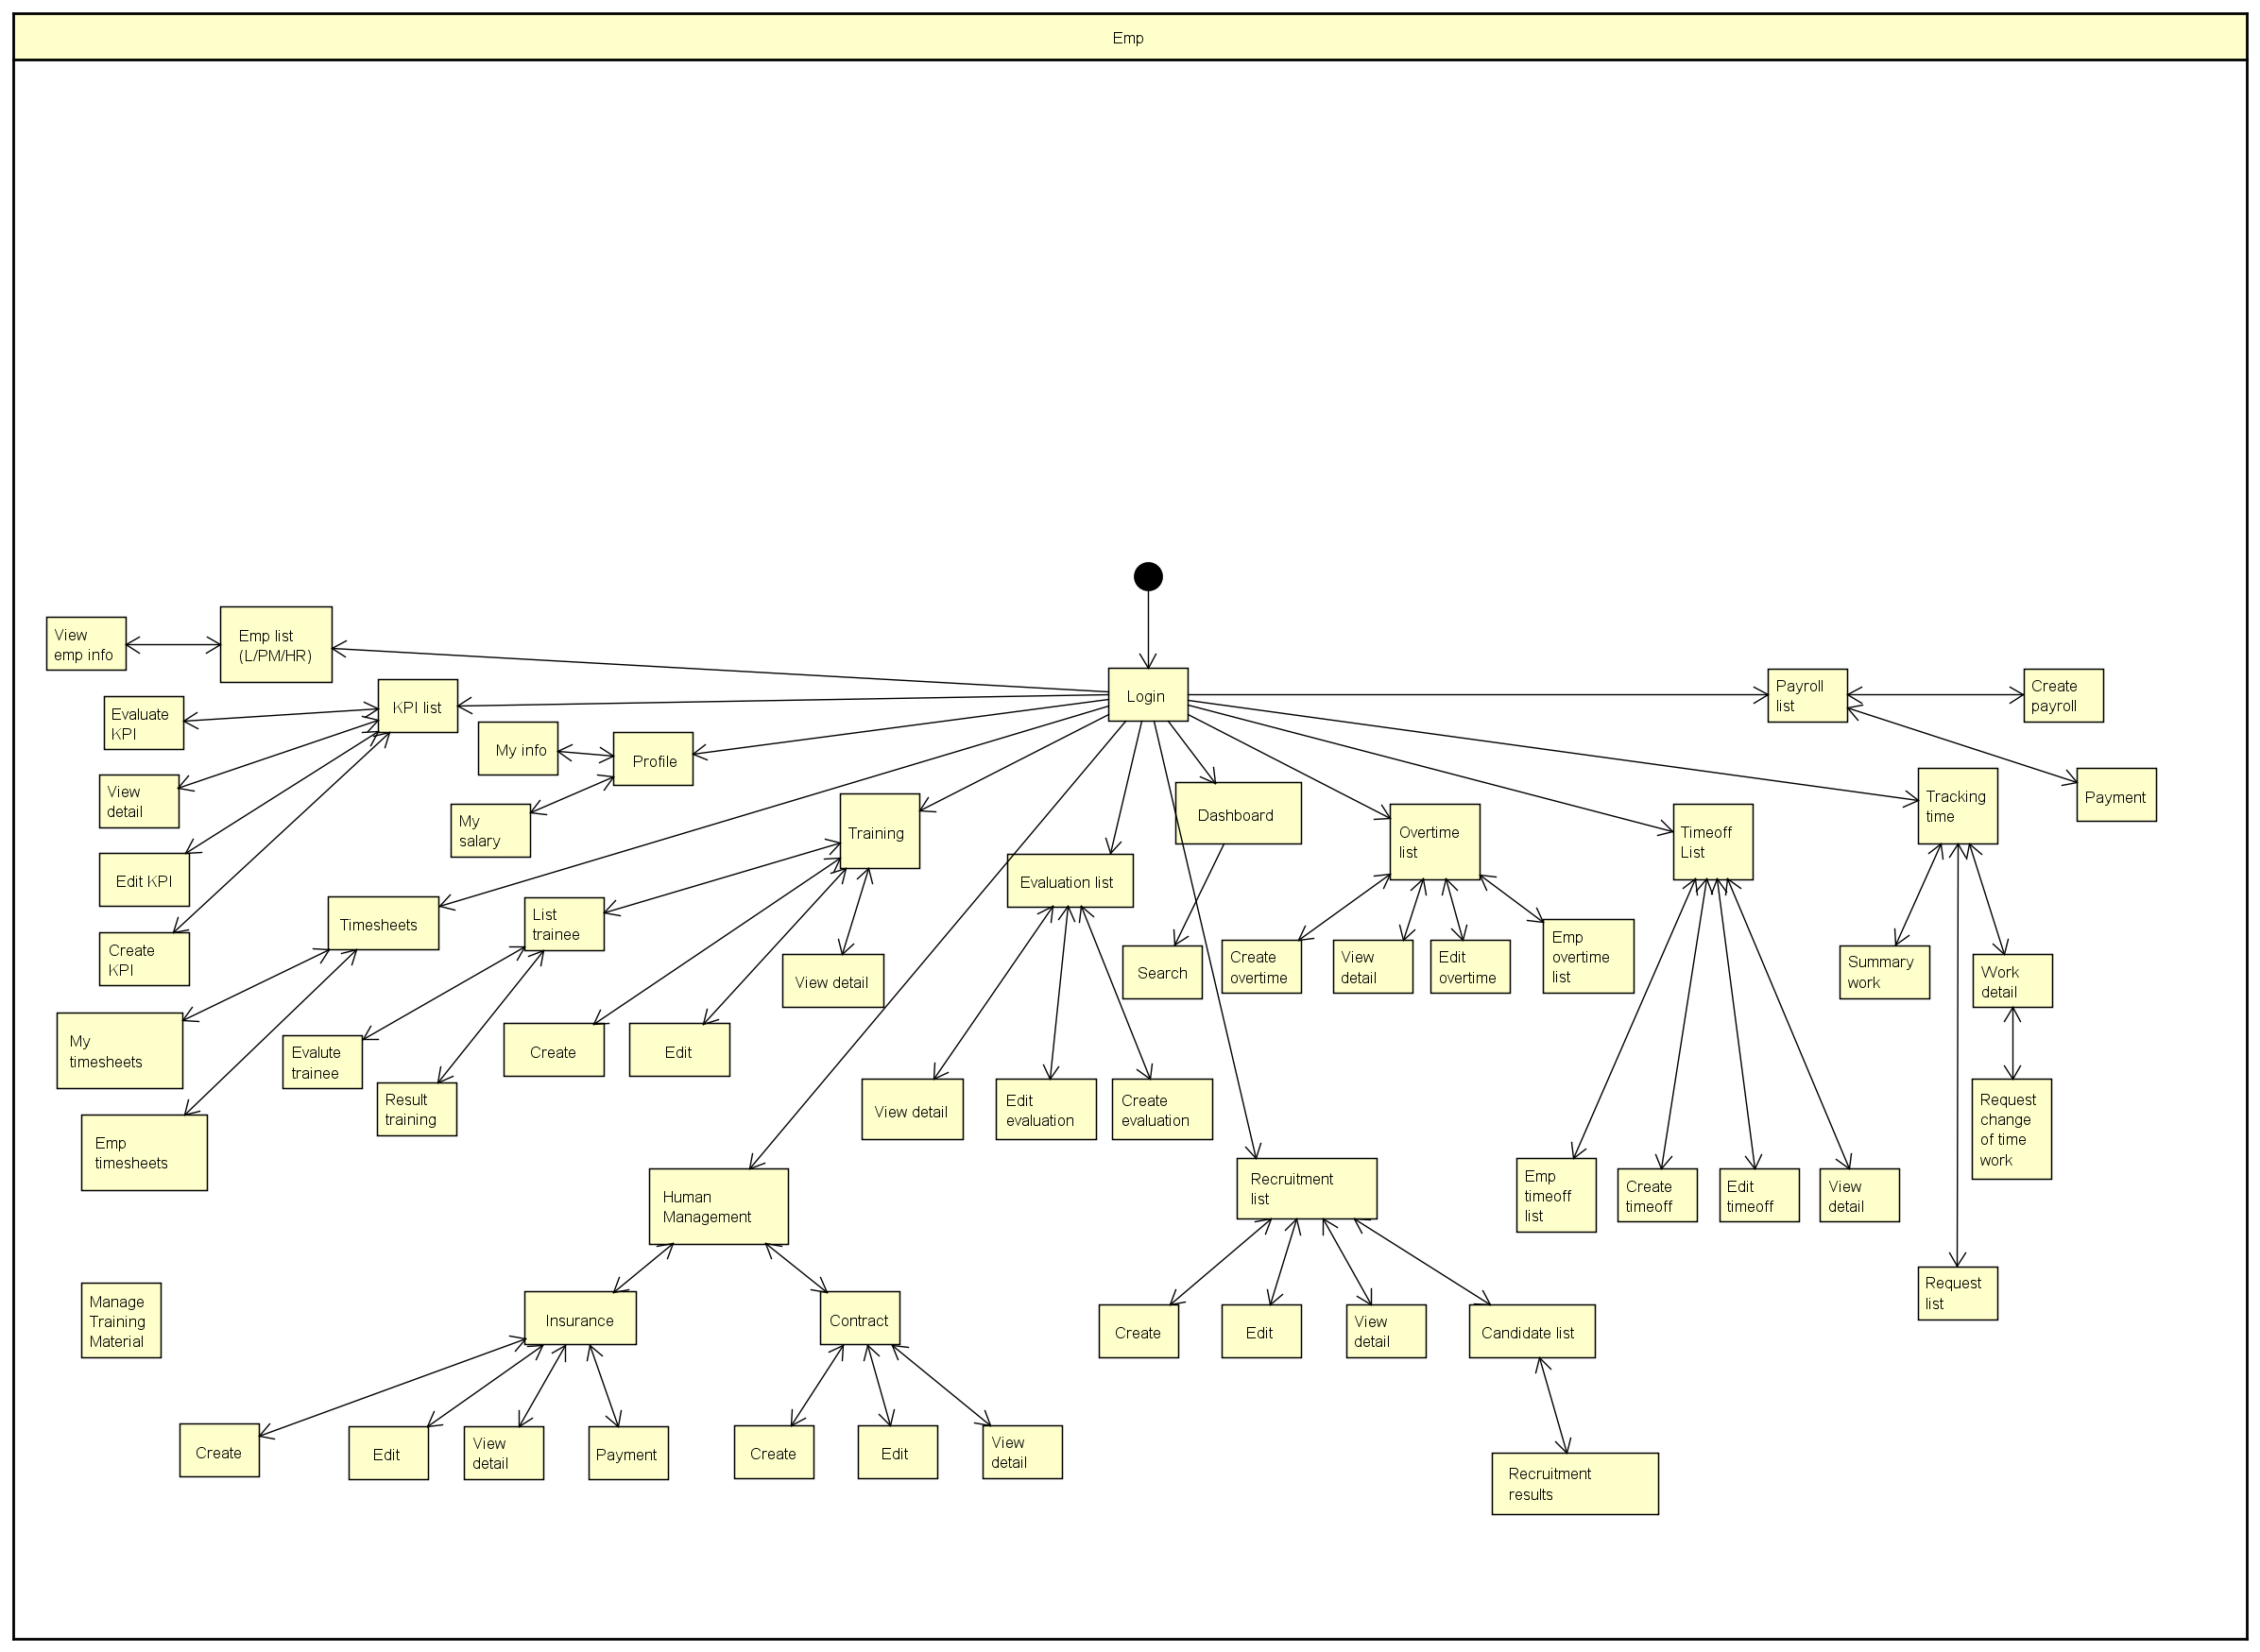

Hình 8 - Screen flow of employee role

### 3.1.2 UC-C001 – Login

|  |  |
| --- | --- |
| Description | Allow the user login into application |
| Pre-condition | N/A |
| Steps | 1. The Login screen is displayed 2. The user shall input username and password at Login Screen 3. The application SHALL send log in request onto server to verifying. 4. The server SHALL send the status of feedback to requested client. |
| Result | * 1. In case the user name & password are correct, show Dashboard screen   2. In case the user name & password are incorrect, show error message “Username or password are incorrect”   3. In case the user name or password is empty, show error message “Username not entered” or “Password not entered” |

### 3.1.3 UC-C002 – Logout

|  |  |
| --- | --- |
| Description | Allow the user sign out of application |
| Pre-condition | User logged in |
| Steps | 1. The User shall choose Logout 2. The Application send request logout to Server 3. The server shall delete a token and response to client |
| Result | The user can logout, show Login screen |

### 

### 3.1.4 UC-C003 – View profile

|  |  |
| --- | --- |
| Description | Allow the user view my profile |
| Pre-condition | User logged in |
| Steps | 1. The user shall access menu “My profile” 2. The application shall sends requests for information to the server 3. The server shall verify and response to the client |
| Result | The application shall show personal information fully |

### 3.1.5 UC-C004 – View salary

|  |  |
| --- | --- |
| Description | Allow the user view my profile |
| Pre-condition | User logged in |
| Steps | 1. The user shall access menu “My profile” 2. The application shall sends requests for information to the server 3. The server shall verify and response to the client |
| Result | The application shall show personal information fully |

### 3.1.6 UC-C005 – View salary

|  |  |
| --- | --- |
| Description | Allow the user view my salary infor |
| Pre condition | User logged in |
| Steps | 1. The user shall access menu “My salary” 2. The application shall send request to the server 3. The server shall check and response to application |
| Result | * 1. In case searching has resulted, application display as a list. Each record is a monthly salary information   2. In case searching no result, show message “No record” |

### 3.1.7 UC-C006 – View time off list

|  |  |
| --- | --- |
| Description | Allow the user view my time off list |
| Pre condition | User logged in |
| Steps | 1. The user shall access menu “My Time off list” 2. The application shall send request to the server 3. Server shall response data to the application |
| Result | 3.1 In case data already exist, the application shall display as a list. In a record has actions by status.  + Created : view, edit, delete, send to leader  + Waiting approval, Approved, Rejected : only view action  3.2 In case no data, the application shall message “ no record” |

### 3.1.8 UC-C007 – Create request for time off

|  |  |
| --- | --- |
| Description | Allow the user create a request for time off |
| Pre condition | User logged in |
| Steps | 1. The user shall access menu “Create time off” 2. The application shall display Create screen with fields 3. The user shall choose or input information and save 4. The application shall verify data is input |
| 4.1 if data valid ( maxlength, minlength, type, required….), the application shall send data to the server  4.2 if data invalid ( maxlength, minlength, type, required….), the application show error message |
| 1. The server shall save data and response to the application |
| Result | * 1. If the data is saved successfully, the application show message “ Successful”, redirect to My Time off list screen.   In case the user click Save button, record is created shall display Created status  In case the user click Save and Send button, record is created shall display Waiting approval status   * 1. If the data isn’t save, the application shall show error message “Fail”, keep the current screen |

### 3.1.9 UC-C008 – Edit request for time off

|  |  |
| --- | --- |
| Description | Allow the user edit request for time off |
| Pre conditon | User logged in  Time off request in Created state |
| Steps | 1. The user shall access menu “My Time off list” 2. The application shall display time off list with Edit action is enabled or is displayed 3. The user shall click Edit icon 4. The application shall display Edit screen with data at creation time 5. The user shall edit data and save 6. The application shall verify data in form |
|  | 6.1 if data valid ( maxlength, minlength, type, required….), the application shall send data to the server  6.2 if data invalid ( maxlength, minlength, type, required….), the application show error message |
|  | 1. The server shall save data and response to application |
| Result | * 1. If the data is saved successfully, the application show message “ Successful”, redirect to My Time off list screen.   In case the user click Save button, record is created shall display Created status  In case the user click Save and Send button, record is created shall display Waiting approval status   * 1. If the data isn’t save, the application shall show error message “Fail”, keep the current screen |

### 3.1.10 UC-C009 – Delete request for time off

|  |  |
| --- | --- |
| Description | Allow the user delete a request for time off |
| Pre condition | User logged in  Time off request in Created state |
| Steps | 1. The user shall access menu “My Time off list” 2. The application shall display My Time off list screen 3. The user shall click delete icon 4. The application shall display confirm popup 5. The user shall choose “yes” option 6. The application send delete request to the server 7. The server shall update data into the database and response to the application |
| Result | Record disappear from list |

### 3.1.11 UC-C010 – View overtime list

|  |  |
| --- | --- |
| Description | Allow the user view my overtime list |
| Pre condition | User logged in |
| Steps | 1. The user shall access menu “My overtime list” 2. The application shall send request to the server 3. Server shall response data to the application |
| Result | 3.1 In case data already exist, the application shall display as a list. In a record has actions by status.  + Created : view, edit, delete, send to leader  + Waiting approval, Approved, Rejected : only view action  3.2 In case no data, the application shall message “ No record” |

### 3.1.12 UC-C011 – Create request for Overtime

|  |  |
| --- | --- |
| Description | Allow the user create a request for overtime |
| Pre condition | User logged in |
| Steps | 1. The user shall access menu “Create Overtime” 2. The application shall display Create screen with fields 3. The user shall choose or input information and save 4. The application shall verify data is input |
| 4.1 if data valid ( maxlength, minlength, type, required….), the application shall send data to the server  4.2 if data invalid ( maxlength, minlength, type, required….), the application show error message |
| 1. The server shall save data and response to the application |
| Result | * 1. If the data is saved successfully, the application show message “ Successful”, redirect to My Overtime list screen.   In case the user click Save button, record is created shall display Created status  In case the user click Save and Send button, record is created shall display Waiting approval status  5.2 If the data isn’t save, the application shall show error message “Fail”, keep the current screen |

### 3.1.13 UC-C012 – Edit request for Overtime

|  |  |
| --- | --- |
| Description | Allow the user edit request for Overtime |
| Pre conditon | User logged in  Time off request in Created state |
| Steps | 1. The user shall access menu “My Overtime list” 2. The application shall display time off list with Edit action is enabled or displayed 3. The user shall click Edit icon 4. The application shall display Edit screen with data at creation time 5. The user shall edit data and save 6. The application shall verify data in form |
|  | 6.1 if data valid ( maxlength, minlength, type, required….), the application shall send data to the server  6.2 if data invalid ( maxlength, minlength, type, required….), the application show error message |
|  | 1. The server shall save data and response to application |
| Result | * 1. If the data is saved successfully, the application show message “ Successful”, redirect to My Overtime list screen.   In case the user click Save button, record is created shall display Created status  In case the user click Save and Send button, record is created shall display Waiting approval status   * 1. If the data isn’t save, the application shall show error message “Fail”, keep the current screen |

### 3.1.14 UC-C013 – Delete request for Overtime

|  |  |
| --- | --- |
| Description | Allow the user delete a request for time off |
| Pre condition | User logged in  Time off request in Created state |
| Steps | 1. The user shall access menu “My Time off list” 2. The application shall display My Time off list screen 3. The user shall click delete icon 4. The application shall display confirm popup 5. The user shall choose “yes” option 6. The application send delete request to the server 7. The server shall update data into the database and response to the application |
| Result | Record disappear from list |

### 3.1.15 UC-C014 – Declare timesheets

|  |  |
| --- | --- |
| Description | Allow the user declare personal timesheets |
| Pre condition | User logged in  Declaration time is not locked |
| Steps | 1. The user shall access menu “My timesheets” 2. The application shall display week calendar, default is current week 3. The user shall input data into fields and save 4. The application shall verify data in form |
|  | 4.1 If data valid (max, min, type, required…), the application send data to the server  4.2 If data invalid (max, min, type, required…), the application show error message |
|  | 1. The server check data is received and response to the application |
| Result | * 1. In case the user log work into off day, the application show message “Log work into off day”   2. In case the user log work with time more than detail Attendance machines, the application show message “Log work time are incorrect” |

### 3.1.16 UC-C015 – View public holiday

|  |  |
| --- | --- |
| Description | Allow the user View public holiday |
| Pre condition | User logged in |
| Steps | 1. The user shall access menu “My timesheets” 2. The application shall display week calendar |
| Result | The holidays will be marked on the calendar |

### 3.1.17 UC-C016 – View work detail

|  |  |
| --- | --- |
| Description | Allow the user view time worked detail |
| Pre condition | User logged in |
| Steps | 1. The user shall access menu “Work detail” and input search criteria 2. The application shall send request to the server to get data 3. The server verify and response to the application |
| Result | * 1. In case data exist, the application display time worked detail of employee by date. Each record is data of one day   2. In case no data, the application show message “No record” |

### 3.1.18 UC-C017 – View work summary

|  |  |
| --- | --- |
| Description | Allow the user view time worked summary |
| Pre condition | User logged in |
| Steps | 1. The user shall access menu “Work summary” and input search criteria 2. The application shall send request to the server to get data 3. The server verify and response to the application |
| Result | * 1. In case data exist, the application display time worked detail of employee by date. Each record is data aggregate in period time   2. In case no data, the application show message “No record” |

### 3.1.19 UC-C018 – Request change time of work

|  |  |
| --- | --- |
| Description | Allow the user create request change time of work |
| Pre condition | User logged in |
| Steps | 1. The user shall access menu “Work detail” and input search criteria 2. The application shall send request to the server to get data 3. The server verify and response to the application 4. The application shall display worked detail of employee as a list. Each record is data by date 5. The user shall click an Adjust icon at record you want to adjust 6. The application shall display a dialog with text field 7. The user shall input request content and send 8. The application shall verify data |
|  | * 1. If data valid (max, min, required…), the application send data to the server   2. If data invalid (max, min, required…), the application show error message |
|  | 1. The server shall save data and response to the application |
| Result | * 1. In case saved successfull, the application display message “Successful”. Redirect to Request list and add a record with Waiting approval status   2. In case isn’t saved successfull, the application display message “Fail”, keep current screen |

### 3.1.20 UC-C019 – View KPI list

|  |  |
| --- | --- |
| Description | Allow the user view KPI list is assigned by leader |
| Pre condition | User logged in |
| Steps | 1. The user shall access menu “KPI list” 2. The application shall send request to the server 3. The Server shall response data to the application |
| Result | 3.1 In case data already exist, the application shall display as a list. In a record has actions: view detail  3.2 In case no data, the application shall message “ No record” |

### 3.1.21 UC-C020– View KPI detail

|  |  |
| --- | --- |
| Description | Allow the user view KPI detail |
| Pre condition | User logged in  KPI list has data valid |
| Steps | 1. At KPI list screen, the user click an View icon 2. The application shall send request to the server to get data 3. The Server shall response data to the application |
| Result | The application shall display specific criteria of KPI and feedback of all employees  If KPI in Processing state, the application enable feedback function  If KPI is completed, feedback function is disabled |

### 3.1.22 UC-C021– Feedback on KPI

|  |  |
| --- | --- |
| Description | Allow the user feedback on KPI |
| Pre condition | User logged in  KPI list has data valid with Processing status |
| Steps | 1. At KPI list screen, the user click an View icon 2. The application shall send request to the server to get data 3. The server shall response data to the application 4. The application shall display KPI detail screen with textfield to input your feedback 5. The user shall input feedback and send 6. The application verify data |
|  | * 1. If data valid (max, min, required…), the application send data to the server   2. If data invalid (max, min, required…), the application show error message |
|  | 1. The server sace data and response to the application |
| Result | * 1. In case saved successfull, the application display message “Successful”. Your comment shall display in feedback group of KPI detail screen   In case isn’t saved successfull, the application display message “Fail” |

### 3.1.23 UC-C022– View evaluation list

|  |  |
| --- | --- |
| Description | Allow the user view evaluation list |
| Pre condition | User logged in |
| Steps | 1. The user shall access menu “Evaluation list” 2. The application shall send request to the server 3. The server shall response data to the application |
| Result | 3.1 In case data already exist, the application shall display as a list. In a record has actions: view detail, evaluate  3.2 In case no data, the application shall message “ No record” |

### 3.1.24 UC-C023– Implement evaluation

|  |  |
| --- | --- |
| Description | Allow the user implement a evaluation |
| Pre condition | User logged in  Evaluation list has data valid with Processing status |
| Steps | 1. At KPI list screen, the user click an Evaluate icon 2. The application shall send request to the server to get data 3. The server shall response data to the application 4. The application shall display Implement evaluation screen 5. The user shall input data and click an Save and send button 6. The application verify data |
|  | * 1. If data valid (max, min, required…), the application send data to the server   2. If data invalid (max, min, required…), the application show error message |
|  | 1. The server save data and response to the application |
| Result | * 1. In case saved successfull, the application display message “Successful”. The number of evaluated has increased to 1 In case isn’t saved successfull, the application display message “Fail” |

### 3.1.25 UC-C024– View training list

|  |  |
| --- | --- |
| Description | Allow the user view training list is attended |
| Pre condition | User logged in |
| Steps | 1. The user shall access menu “My training list” 2. The application shall send request to the server 3. The server shall response data to the application |
| Result | 3.1 In case data already exist, the application shall display data as a list. In a record has actions: view detail  3.2 In case no data, the application shall message “ No record” |

### 3.1.26 UC-C025– View training detail

|  |  |
| --- | --- |
| Description | Allow the user view a course detail is attended  Training list has data |
| Pre condition | User logged in |
| Steps | 1. At KPI list screen, the user click an view detail icon 2. The application shall send request to the server to get data 3. The server shall response data to the application |
| Result | The application shall display traning course detail with document. The application allow download document is attached in course |

### 3.1.27 UC-C026– Do exercises

|  |  |
| --- | --- |
| Description | Allow the user attach exercises file and send |
| Pre condition | User logged in |
| Steps | 1. The user shall access menu “Do exercises” 2. The application shall display search traning session 3. The user shall input search condition 4. The application shall send data to the server 5. The server shall response data to the application |
| Result | 5.1 In case data already exist, the application shall display training session  5.2 In case no data, the application shall message “ No record” |

**2.2.2.2 Use case với vai trò leader**

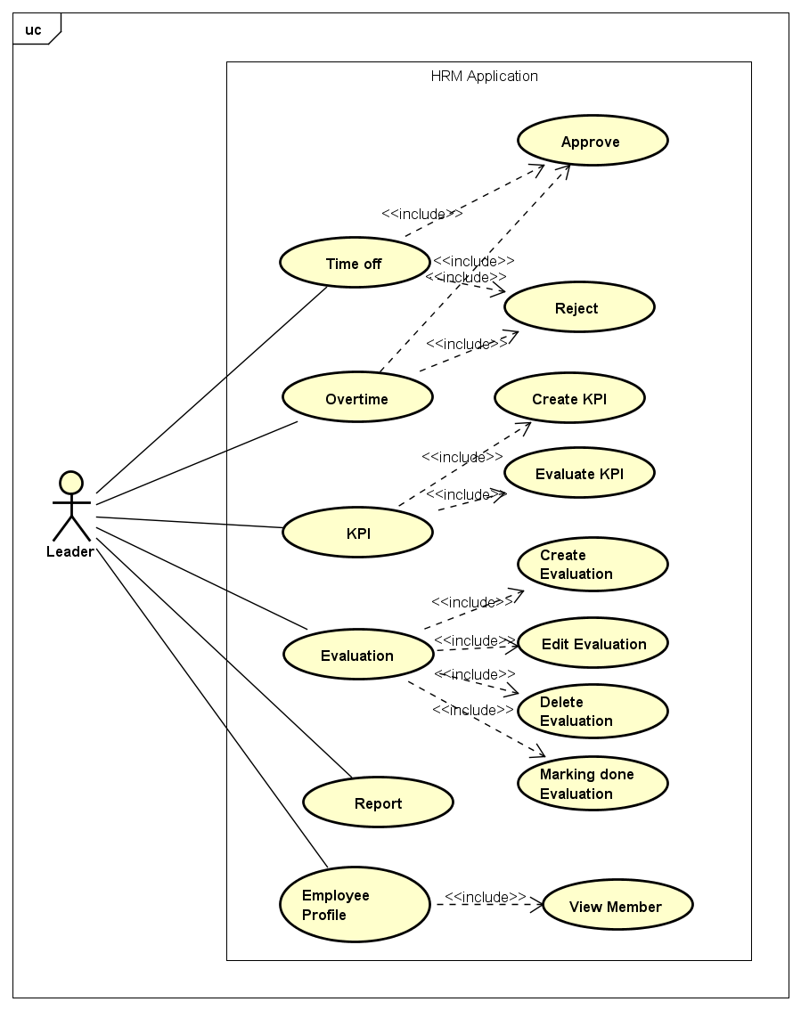

Hình 5: Use case của actor Leader

|  |  |  |
| --- | --- | --- |
| **No.** | **Use Case Name** | **Description** |
| UC-C023 | View time off list | Cho phép xem danh sách các yêu cầu xin nghỉ cần xử lý |
| UC-C024 | Approve request for time off | Cho phép phê duyệt một yêu cầu xin nghỉ hợp lệ |
| UC-C025 | Reject request for time off | Cho phép Từ chối một yêu cầu xin nghỉ |
| UC-C026 | View Overtime list | Cho phép xem và thống kê các yêu cầu tăng ca cần xử lý |
| UC-C027 | Approve request for overtime | Cho phép duyệt một yêu cầu tăng ca hợp lệ |
| UC-C028 | Reject request for overtime | Cho phép từ chối một yêu cầu tăng ca không hợp lệ |
| UC-C029 | View KPI list | Cho phép xem danh sách KPI đã được tạo |
| UC-C030 | Create KPI | Cho phép tạo mới KPI gồm các chỉ tiêu và danh sách người thực hiện |
| UC-C031 | Edit KPI | Cho phép sửa thông tin KPI khi KPI chưa được publish đến nhân viên |
| UC-C032 | Delete KPI | Cho phép xóa KPI khi KPI chưa được publish đến nhân viên |
| UC-C033 | Evaluate KPI | Cho phép leader thực hiện đánh giá kết quả thực hiện KPI |
| UC-C034 | View Evaluation list | Cho phép xem danh sách các đợt đánh giá đã tạo |
| UC-C035 | Create Evaluation | Cho phép tạo mới một đợt đánh giá |
| UC-C036 | Edit Evaluation | Cho phép sửa thông tin một đợt đánh giá khi đợt đánh giá chưa được publish |
| UC-C037 | Delete Evaluation | Cho phép xóa một đợt đánh giá khi đợt đánh giá chưa được publish |
| UC-C038 | Marking done evaluation | Cho phép leader đánh dấu hoàn thành đợt đánh giá khi hoàn tất đánh giá |
| UC-C039 | View member | Cho phép xem danh sách và thông tin chi tiết hiện đang quản lý |
| UC-C040 | Report | Cho phép thống kê báo cáo một số thông tin về đánh giá nhân viên, đánh giá KPI… |

**2.2.2.3 Use case với vai trò manager**

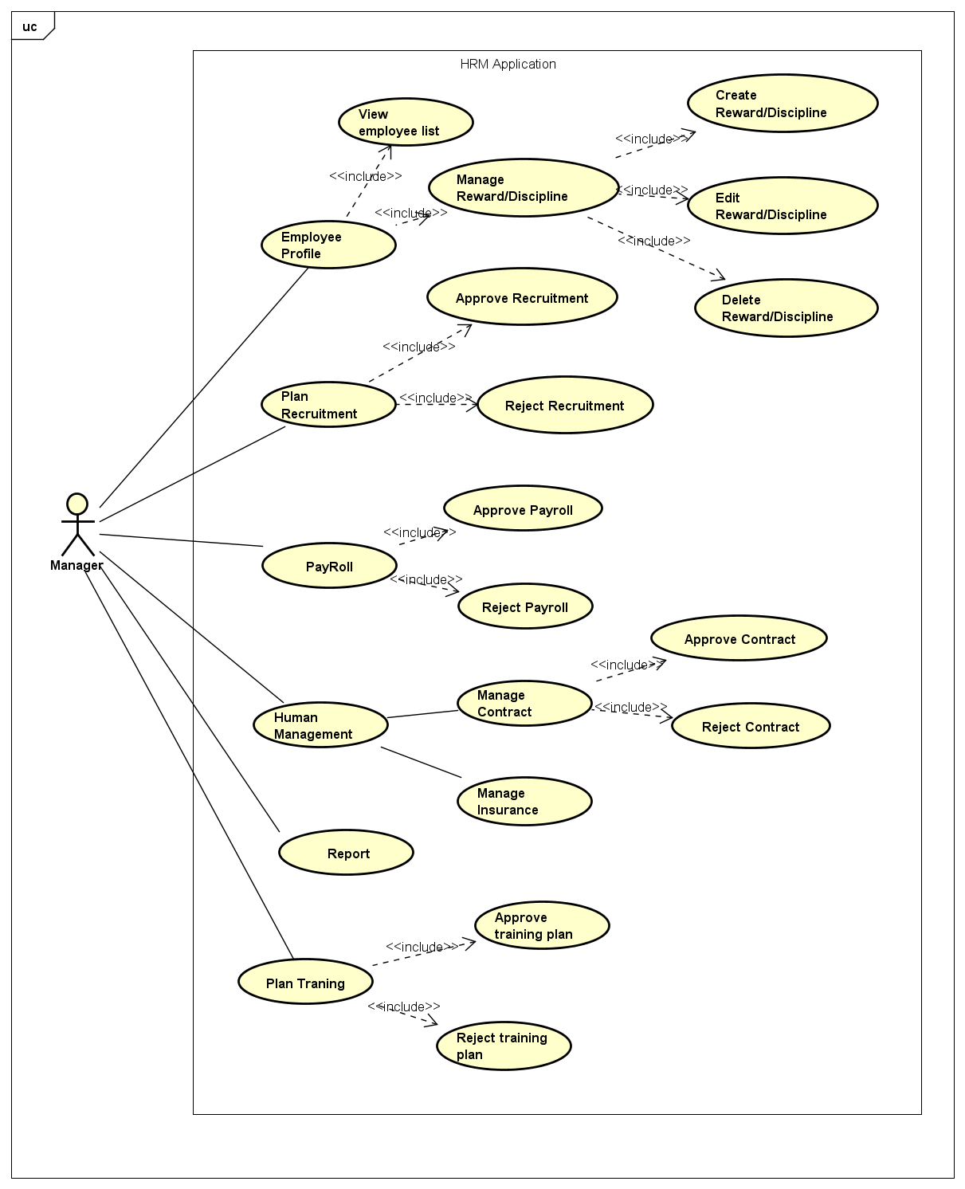

Hình 6: Use case của actor Manager

|  |  |  |
| --- | --- | --- |
| **No.** | **Use Case Name** | **Description** |
| UC-C041 | View Reward/ Discipline list | Cho phép xem danh sách các đợt khen thưởng/ kỷ luật |
| UC-C042 | Create Reward/ Discipline list | Cho phép tạo mới một thông báo thưởng phạt |
| UC-C043 | Edit Reward/ Discipline list | Cho phép sửa một thông báo thưởng phạt khi chưa publish |
| UC-C044 | Delete Reward/ Discipline list | Cho phép xóa một thông báo thưởng phạt khi chưa publish |
| UC-C045 | View Recruitment plan list | Cho phép xem danh sách các kế hoạch tuyển dụng |
| UC-C046 | Approve Recruitment plan | Cho phép phê duyệt kế hoạch tuyển dụng |
| UC-C047 | Reject Recruitment plan | Cho phép từ chối một kế hoạch tuyển dụng |
| UC-C048 | View Payroll list | Cho phép xem danh sách bảng lương cần xử lý |
| UC-C049 | Approve Payroll | Cho phép phê duyệt bảng lương |
| UC-C050 | Reject Payroll | Cho phép từ chối duyệt bảng lương |
| UC-C051 | Contract list | Cho phép xem danh sách các hợp đồng cần xử lý |
| UC-C052 | Approve Contract | Cho phép duyệt thông tin hợp đồng của nhân viên |
| UC-C053 | Reject Contract | Cho phép từ chối duyệt thông tin hợp đồng của nhân viên |
| UC-C054 | Training list | Cho phép xem danh sách các khóa đào tạo cần xử lý |
| UC-C055 | Approve training plan | Cho phép phê duyệt kế hoạch tuyển dụng |
| UC-C056 | Reject training plan | Cho phép từ chối kế hoạch tuyển dụng |
| UC-C057 | View employee list | Cho phép manager xem danh sách nhân viên và thông tin chi tiết |

**2.2.2.4 Use case với vai trò HR**

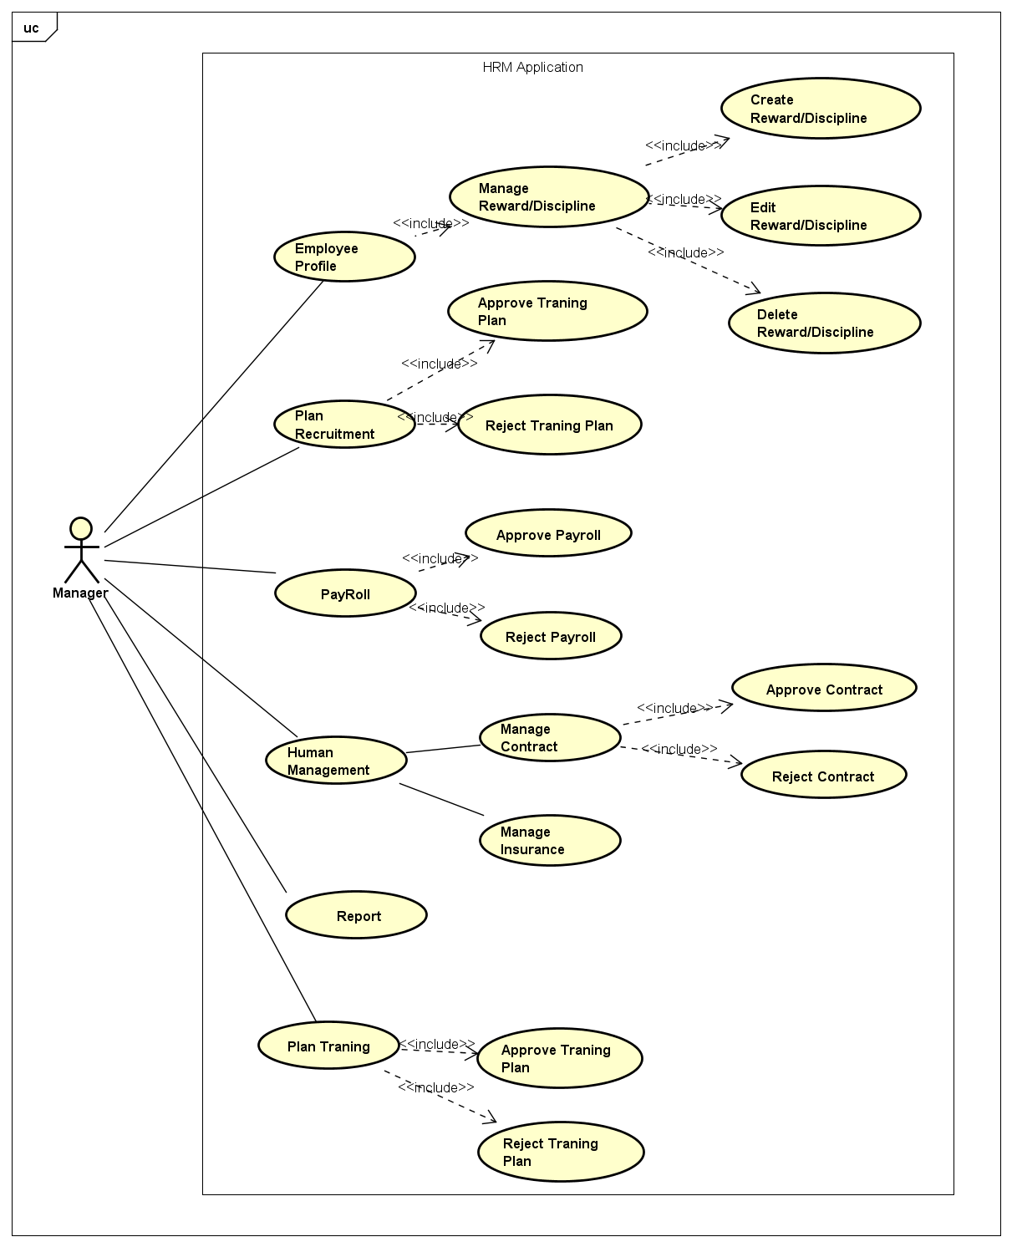

Hình 7: Use case của actor Leader

|  |  |  |
| --- | --- | --- |
| **No.** | **Use Case Name** | **Description** |
| UC-C001 | View Reward/ Discipline list | Cho phép xem danh sách các đợt khen thưởng/ kỷ luật |
| UC-C002 | Create Reward/ Discipline list | Cho phép tạo mới một thông báo thưởng phạt |
| UC-C003 | Edit Reward/ Discipline list | Cho phép sửa một thông báo thưởng phạt khi chưa publish |
| UC-C004 | Delete Reward/ Discipline list | Cho phép xóa một thông báo thưởng phạt khi chưa publish |
| UC-C005 | Approve Recruitment plan | Cho phép phê duyệt kế hoạch tuyển dụng |
| UC-C006 | Reject Recruitment plan | Cho phép từ chối một kế hoạch tuyển dụng |
| UC-C007 | Approve Payroll | Cho phép phê duyệt bảng lương |
| UC-C008 | Reject Payroll | Cho phép từ chối duyệt bảng lương |
| UC-C009 | Approve Contract | Cho phép duyệt thông tin hợp đồng của nhân viên |
| UC-C010 | Reject Contract | Cho phép từ chối duyệt thông tin hợp đồng của nhân viên |
| UC-C011 | Approve training plan | Cho phép phê duyệt kế hoạch tuyển dụng |
| UC-C012 | Reject training plan | Cho phép từ chối kế hoạch tuyển dụng |
| UC-C013 | View employee list | Cho phép manager xem danh sách nhân viên và thông tin chi tiết |

## 3.3 Supplementary Requirements

### 3.3.1 Deployment Requirements

#### 3.3.1.1 Device requirements

- Android devices

- iOS devices

#### 3.3.1.2 Software requirements

- Android 5.x ~ 8.x

- iOS 7.x ~ 10.x

#### 3.3.1.3 Target devices

- Android: Samsung Galaxy Note 5, Galaxy Note 3

- iOS: IPhone 5s, 6, 6s plus

#### 3.3.1.4 Multilanguage Support

- Supports 2 languages for GUI: Japanese, English.

### 3.3.2 Development Requirements

#### 3.3.2.1 Developer Tools

- Android: Android Studio

- iOS: XCode

#### 3.3.2.2 . Programming language

- Android: Java

- iOS: Swift

- Server: Java

### 3.3.3 Design Constraints

- The application should not crash in any cases

- The application works stable after running continuously at least in one week

- Able to handle error conditions gracefully, without failure

- The application should have a well design to make sure that the changes of the requirement do not break the design

- The application supports running in both Portrait and Landscape mode

- System’s architecture must be flexible enough so that:

- Support Android version 5.x ~ 8x

- Support iOS version 7.x ~ 10.x

- Support smart phone and tablet, iPhone and iPad.

### 3.3.4 Logging convention

#### 3.3.4.1 iOS

***- Log strategy****:*

- The logging should be well designed so that it will be less impact to the performance of the applications.

- Be concise and descriptive. Each logging statement should contain both data and description.

- Log method arguments and return values.

***- Log report****:*

- During development phase, should write logging information to log file.

***- Log format****:* *[Date time] [(File name: Line)] [(Method name)] – [Message Info]*

- [Date time]: yyyy-MM-dd HH:mm:ss.SSS

- [(File name: Line)]: [Name of class and the line number where the log is]

- [(Method name)]: [Name of method where the log is]

- [Message Info]: [message]

#### 3.3.4.2 Android

***- Log strategy:***

- The logging should be well designed so that it will be less impact to the performance of the applications.

- Be concise and descriptive. Each logging statement should contain both data and description.

- Log method arguments and return values.

***- Log report:***

- During development phase, should write logging information to log file

***- Log level:***

- DEBUG: The DEBUG Level designates fine-grained informational events that are most useful to debug an application.

-INFO: The INFO level designates informational messages that highlight the progress of the application at coarse-grained level.

- WARN: The WARN level designates potentially harmful situations.

- ERROR: The ERROR level designates error events that might still allow the application to continue running.

- ASSERT: The ASSERT level designates very severe error events that will presumably lead the application to abort.

- **Log format:** *[Date time] [Log level] – [Message Info]*

- [Date time]: yyyy-MM-dd HH:mm:ss.SSS

- [Log level]: [DEBUG], [INFO], [WARN], [ERROR], [ASSERT]

- [Message Info]: [message]

### 3.3.5 Application Versioning Convention

The application’s version name is a string value that represents the release version of the application code, as it should be shown to users. The version name is versioned following the versioning convention below.

**0.1.0 (build 1) => 0.1.1 (build 2) => 0.1.2 (build 3) => ...**

### 3.3.6 Check Points before Release New Version to Market

- Verify pass for all test cases in test report.

# 4. Supporting Information

## 4.1 Localization

Will define ourselves and apply the translation file with English at first, Japanese will be translated and applied later.

## 4.2 Interface

### 4.2.1 Log in screen

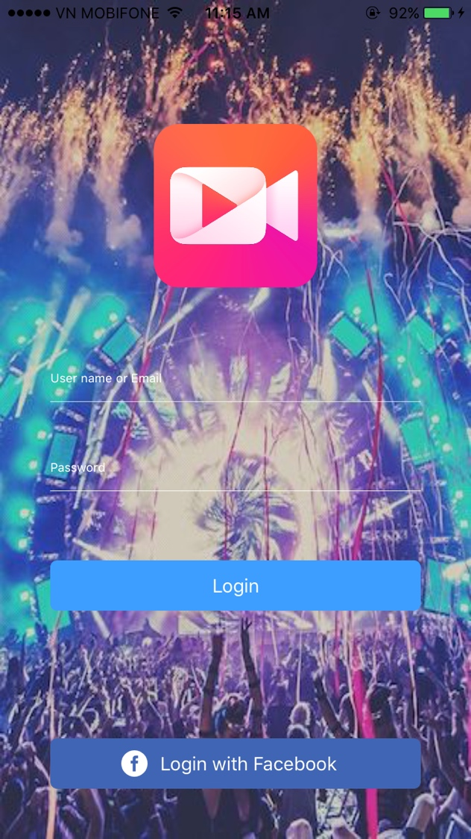

Figure 28 - Log in screen

### 4.2.2 Home screen

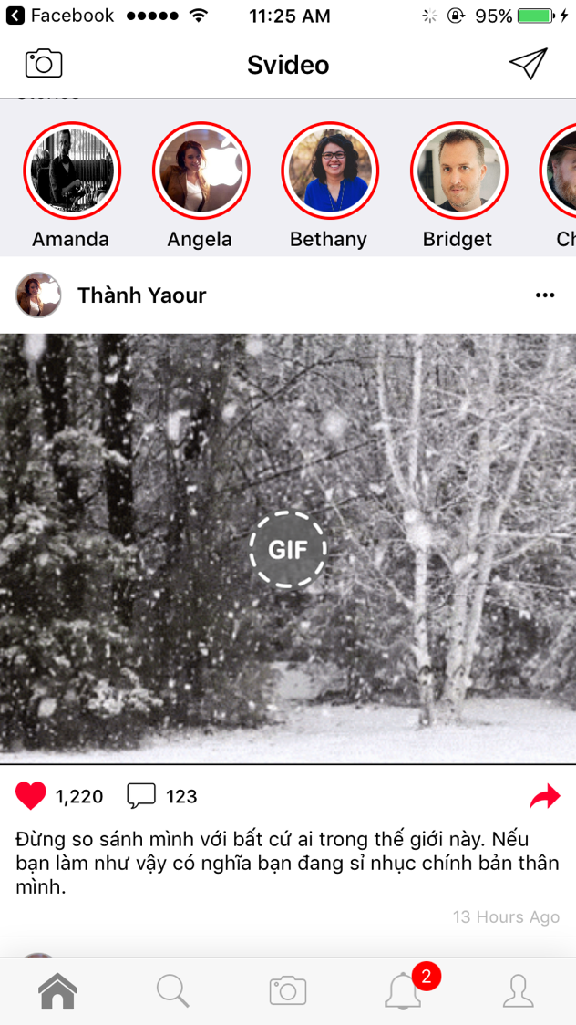

Figure 29 - Home screen

### 4.2.3 Search screen

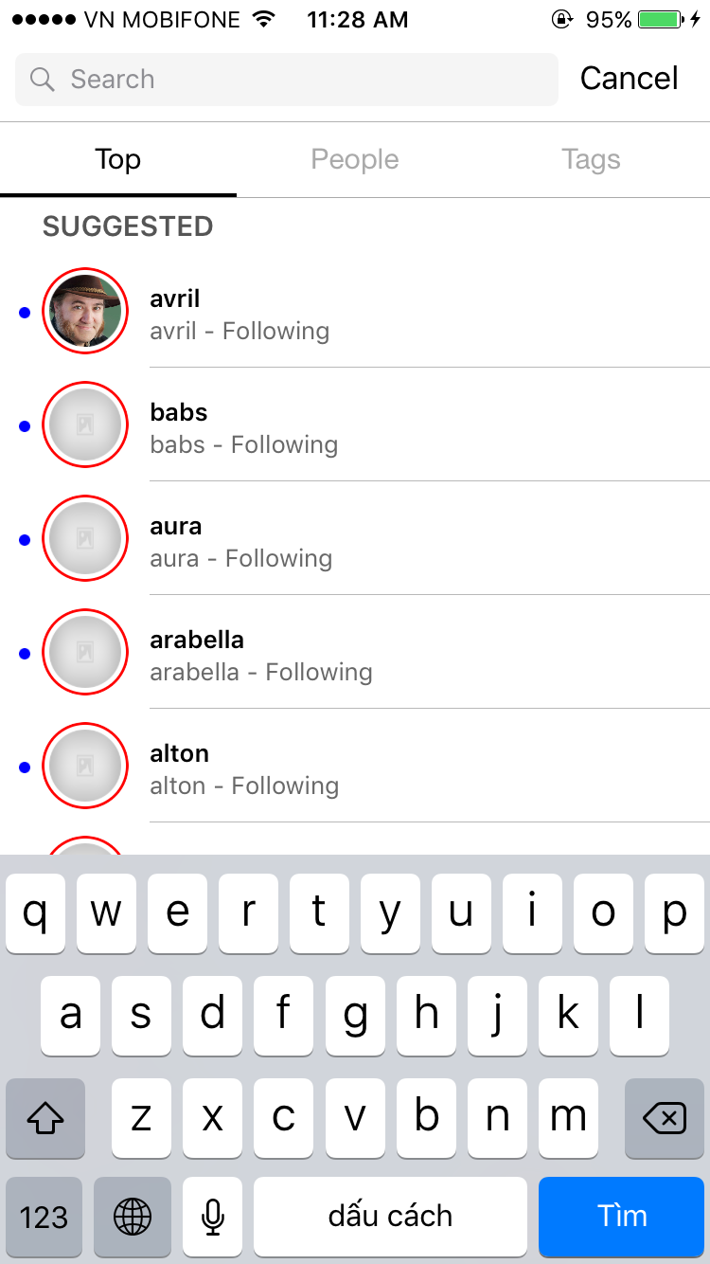

Figure 30 - Search screen

### 4.2.4 Capture Video screen

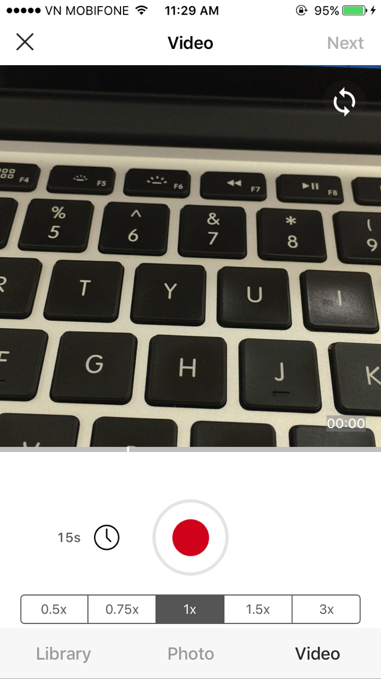

Figure 31 – Capture Video screen

### 4.2.5 Notification screen

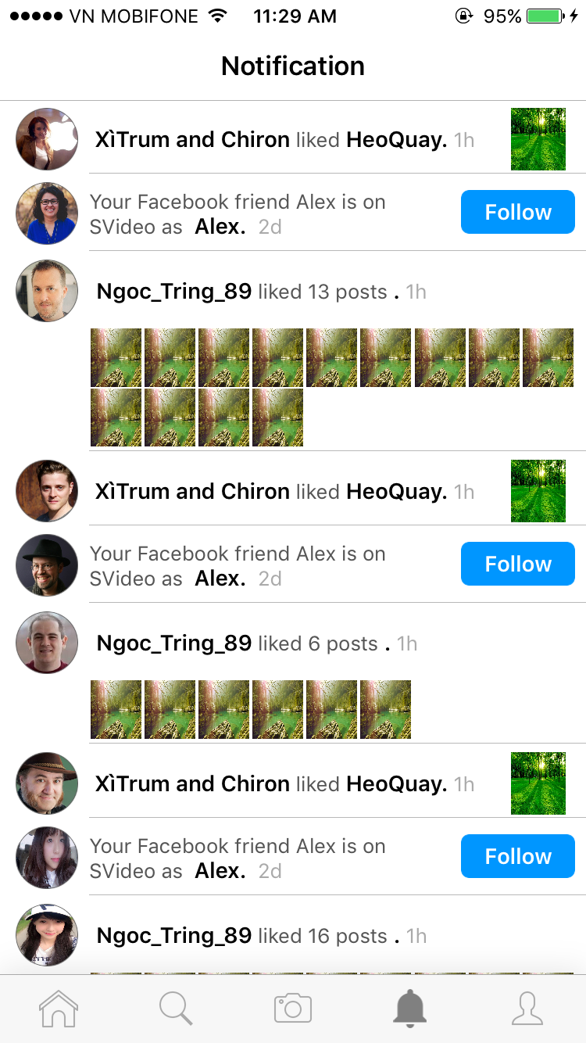

Figure 32 – Notification screen

### 4.2.6 Profile screen



Figure 33 – Profile screen

### 4.2.7 Discover People screen

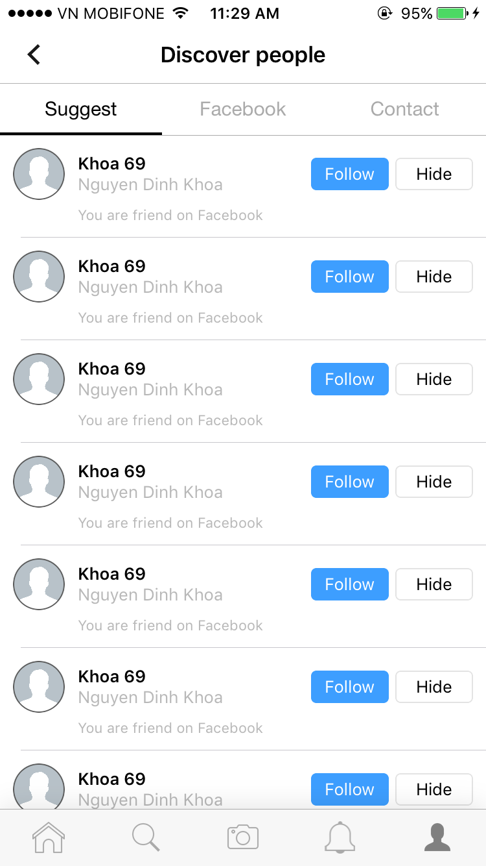

Figure 34 – Discover People screen

### 4.2.8 App Setting screen

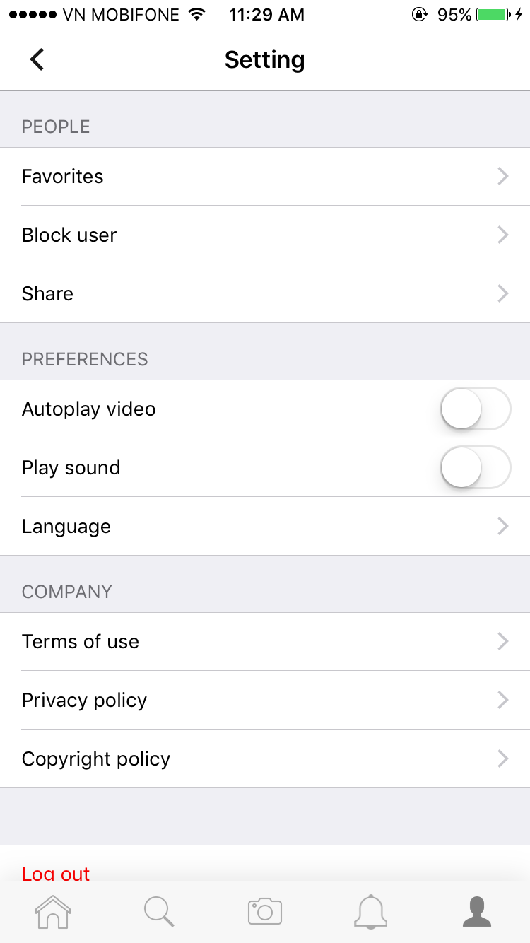

Figure 35 –Application Setting screen

### 4.2.9 User Setting screen

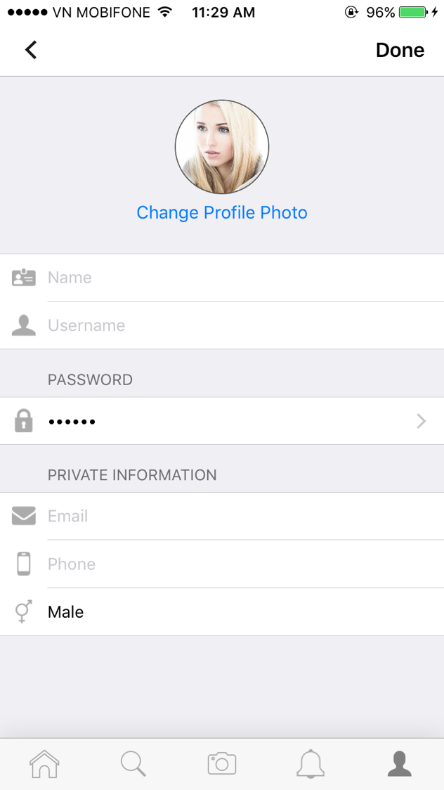

Figure 36 –Application Setting screen